|  |  |  |
| --- | --- | --- |
| **Course Code and Name: CSE209**  **Electrical Circuit** | | |
| **Experiment no: 08** | | |
| **Experiment name:**  **Experimental Study of Sinusoids and Their Characteristics** | | |
| **Semester: Fall 2022** |  | |
| **Name of Student: D.M. Rafiun Bin Masud**  **Student Id:**  2019-3-60-137 | **Course Instructor information:**  **M Saddam Hossain Khan**  **Senior Lecturer, Department of Computer Science and Engineering.** | |
| **Date of Report Submitted:**  07-01-2021 | **Pre-Lab Marks:** |  |
| **Post Lab Marks:** |  |
| **TOTAL Marks:** |  |

# Circuit Diagram (PSpice Simulation):r

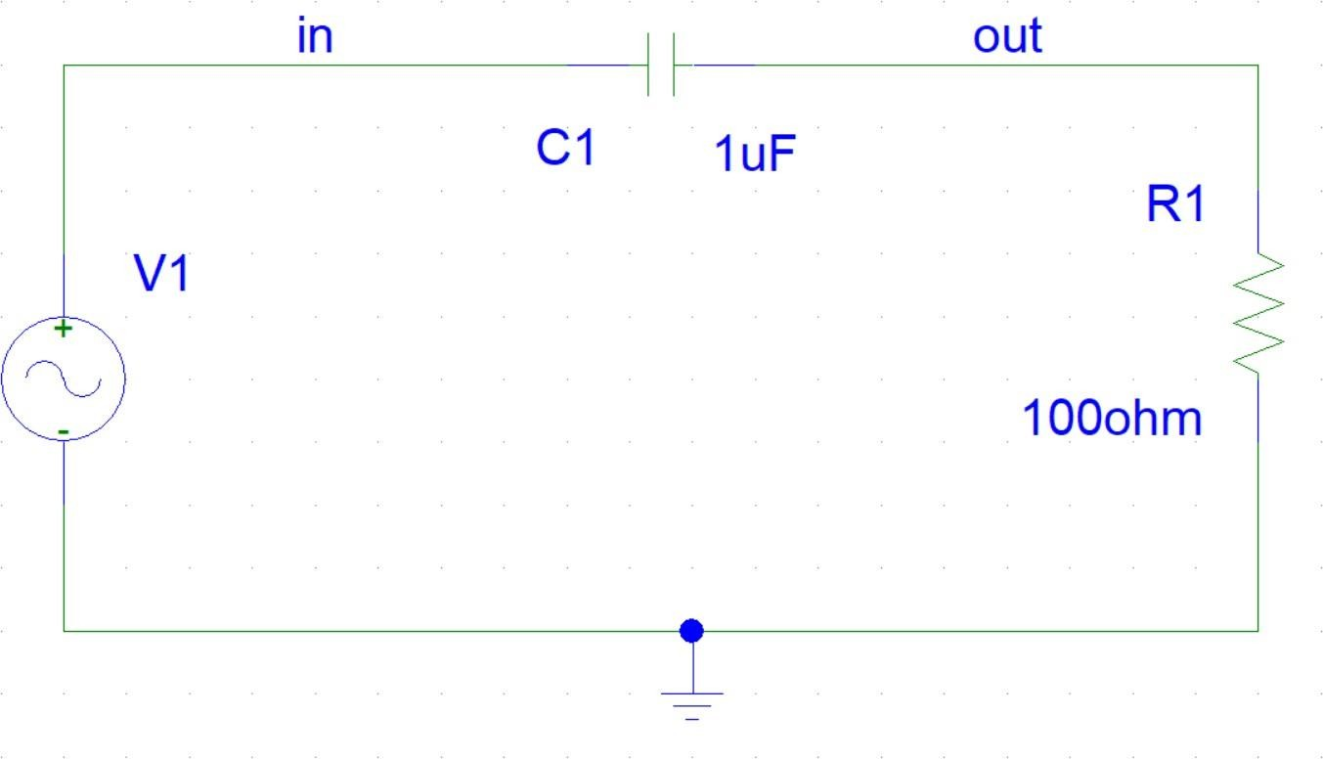

## Figure 1: PSpice Simulation Circuit.

Here,

For voltage sinusoid V1,

Amplitude, Vm = (10/2) V = 5 V Frequency, *f* = 1 KHZ

Capacitance, C1 = 1 µF Resistance, R1 = 100 Ω

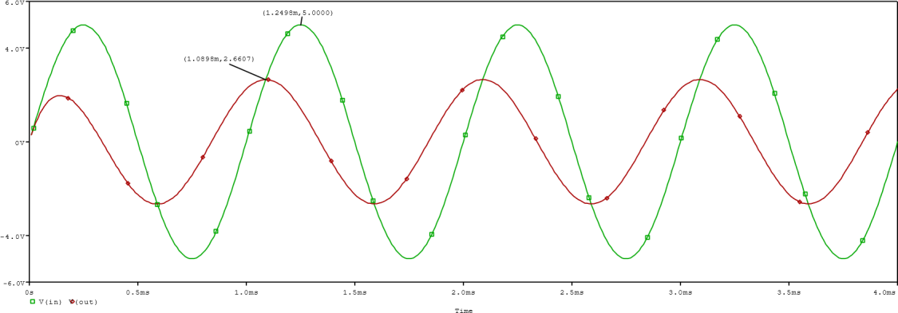

## Figure 2: PSpice Simulation Plot of Vin and Vout.

Here,

Peak value of Vin, Vinpk = 5 V and respect to time, tin = 1.2498 ms

Peak value of Vout, VRpk = 2.6607 V and respect to time, tout = 1.0898 ms

⸫ Peak value of current through resistance,

I(R1) = (VRpk / R1)

= ((2.6607 / 100) * 103) mA =

26.607 mA

|  |  |
| --- | --- |
| Time period,  ⸫ T = 1/*f* |  |
| = (1/1000) s | [⸪*f* = 1K HZ] |

= 1 ms

⸫ Δt = tin - tout

= (1.2498 – 1.0898) ms

= 0.16 ms

Phase Difference, φ =

(Δt/T) * 360°

= (0.16/1) * 360°

= 57.6°

## Table 1. Experimental Data:

|  |  |  |  |  |  |
| --- | --- | --- | --- | --- | --- |
| **Value of resistance (Ω)** | **Set peak- to- peak**  **value of source voltage (V)** | **Set source frequency (KHz)** | **PSpice simulated peak value of current through resistance (mA)** | **PSpice simulated phase difference between voltage and current (deg)** | **Which signal is leading?** |
| 100 | 10 | 1 | 26.607 | 57.6° | Vin |

**Figure 3: PSpice Simulation Plot of Vin and Vout and (Vin - Vout).**

Here,

For source voltage, peak value of Vin, Vinpk = 5 V

For voltage across resistance, peak value of Vout, VRpk = 2.6607 V

For voltage across capacitor, peak value of (Vin - Vout), VCpk = 4.2333 V

We know,

The RMS value of the voltage sinusoid, Vrms = Vm / √2

⸫ RMS value of source voltage,

Vinrms = (Vinpk / √2)

= (5 / √2) V

= 3.54 V

⸫ RMS value of voltage across capacitor, VCrms

= (VCpk / √2)

= (4.2333 / √2) V

= 2.99 V

⸫ RMS value of voltage across resistance,

VRrms = (VRpk / √2)

= (2.6607 / √2) V

= 1.88 V

⸫ RMS value of current through resistance,

IRrms = (VRrms / R1)

= ((1.88 / 100) * 103) mA

= 18.8 mA

## Table 2. Experimental Data:

|  |  |  |  |
| --- | --- | --- | --- |
| **PSpice simulated RMS value of source voltage (V)** | **PSpice simulated RMS value of voltage across**  **capacitor (V)** | **PSpice simulated RMS value of voltage across**  **resistance (V)** | **RMS value of current through resistance (mA)** |
| 3.54 | 2.99 | 1.88 | 18.8 |